Multi-Tier Deployment Demo
Deploying database and application servers in coordinated manner using Ansible.
Database setup
Application server connect after DB is ready
Coordinate all things using ansible, inventory, handlers, roles, playbook.

Created folder named db-app-deploy
Move to that folder and create inventory.yml and playbook.yml
Inventory.yml
all:
hosts:
common-ec2:
ansible_host: 3.80.33.201
ansible_user: ubuntu
ansible_ssh_private_key_file: ~/.ssh/testsonam.pem

children:
db:
hosts:
common-ec2:

app:
hosts:
common-ec2:

playbook.yml
---
- name: Deploy Database Server
hosts: db
become: true
roles:
- db

- name: wait for DB Connect
hosts: db
become: true
tasks:
- name: wait for postgres to listen on the port 5432
wait_for:
port: 5432
host: "localhost"
timeout: 60

- name: Deploy Application Server
hosts: app
become: true
roles:
- app

Create 2 roles under roles folder
Ansible-galaxy init roles/db
Ansible-galaxy init roles/app

Under roles db edit tasks/main.yml (Task for DB)
---
# tasks file for roles/db
- name: Install PostgreSQL
apt:
name: postgresql
state: present
update_cache: yes

- name: Ensure PostgreSQL is Running
service:
name: postgresql
state: started
enabled: true

- name: create application database
become: true
shell: |
sudo -u postgres psql -tc "SELECT 1 FROM pg_database where datname = 'myapp' " | grep -q 1 ||
sudo -u postgres psql -c "CREATE DATABASE myapp;"
args:
executable: /bin/bash

- name: create PostgreSQL User with password
become: true
shell: |
sudo -u postgres psql -tc "SELECT 1 FROM pg_roles WHERE rolname = '{{ DB_USER }}' " | grep -q 1 ||
sudo -u postgres psql -c "CREATE USER {{ DB_USER }} WITH PASSWORD '{{ DB_PASS }}';"
args:
executable: /bin/bash

Defaults/main.yml (for variables creation)
---
# defaults file for roles/db
DB_USER: myappuser
DB_PASS: mysecretpassword

Under role app (Project Code)
Add code under files /app/app.py
from flask import Flask,jsonify
import os
import psycopg2
from psycopg2 import OperationalError
from dotenv import load_dotenv

load_dotenv(dotenv_path='/home/ubuntu/app/.env')

app = Flask(__name__)

def get_db_connection():
try:
conn = psycopg2.connect(
host=os.getenv('DB_HOST'),
database=os.getenv('DB_NAME'),
user=os.getenv('DB_USER'),
password=os.getenv('DB_PASS'),
)
return conn
except OperationalError as e:
print(f"Database connectivity failed: {e}")
return None

@app.route('/')
def hello():
conn = get_db_connection()
if conn:
cur = conn.cursor()
cur.execute("SELECT version();")
db_version = cur.fetchone()
cur.close()
return jsonify({
'status':"Connected to DB",
'DB_Version': db_version[0]
})
else:
return jsonify({
'status':'falied to connect with DB'
}),500

if __name__ == '__main__':
app.run(host='0.0.0.0',port=5000)

Also add tasks/main.yml (Tasks for Backend)
---
# tasks file for roles/app
- name: Install Dependencies
apt:
name: python3-pip
state: present

- name: Install Flask and psycopg2 and dotenv
apt:
name:
- python3-flask
- python3-psycopg2
- python3-dotenv

- name: copy application code
copy:
src: files/app/
dest: /home/ubuntu/app/
mode: '0755'

- name: Set Environment Variables
copy:
dest: /home/ubuntu/app/.env
content: |
DB_HOST=localhost
DB_USER=myappuser
DB_PASS=mysecretpassword
DB_NAME=myapp

- name: Start Flask app
shell: |
FLASK_APP=/home/ubuntu/app/app.py flask run --host=0.0.0.0 --port=5000 &
args:
executable: /bin/bash

Run playbook:
ansible-playbook -i inventory.yml playbook.yml
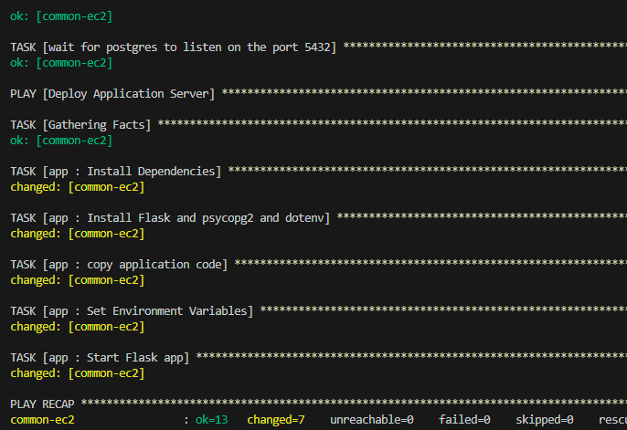

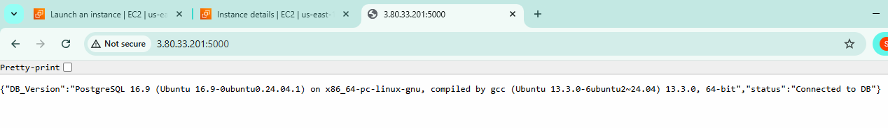
Trigger http://3.80.33.201:5000/
In your case it must be your public ip:5000

